WELLINGTON FIELDS ALLOTMENTS – HIXON Issue # no 12

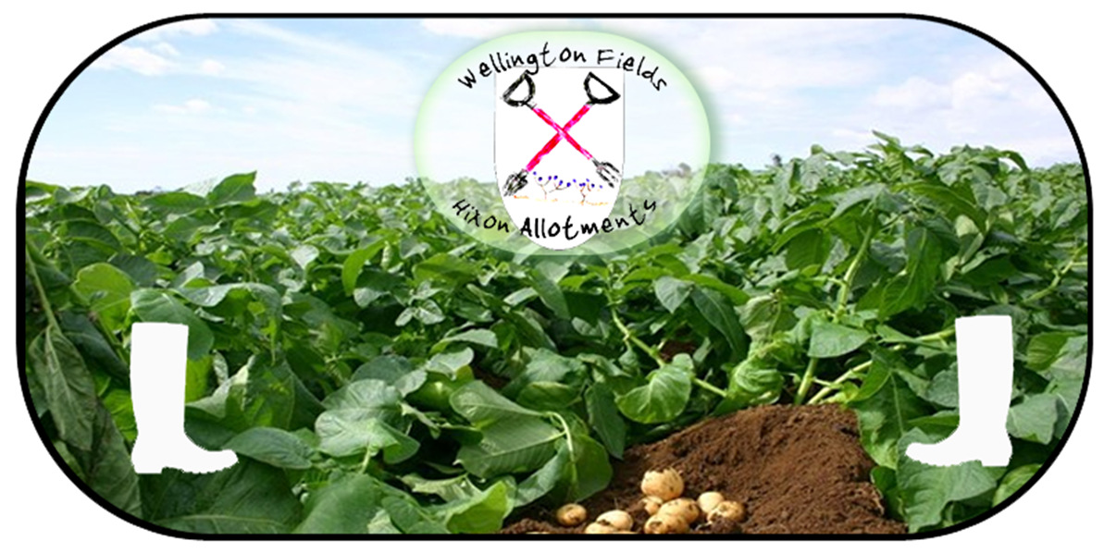
WELLINGTON FIELDS ALLOTMENTS NEWSLETTER

Wellington fields Allotments Newsletter - Winter Edition.
Don't forget, if you wish to contribute to future issues, please contact a member of the committee.

Committee Notices

Winter 2019-20

Quiz Night.
It is intended to run one of our popular Quiz’s on the 26th January of this year, but further details will not be available until nearer to the date and an Email will be sent out to inform you.

Water.
The mains water has now been turned Off for the Winter to prevent any damage and will be turned back on in time for early Spring planting.

Fence Repairs.
John Martin has now put in some new posts to correct and repair the boundary fence that was leaning. We think part of the problem was caused initially by a shed blowing over onto it in one of the storms. Every year we have a few bad storms that blow sheds over, so it is in your own interest to make sure they are properly erected and secure as Winter is now upon us!

Concrete Slabs
The concrete slabs were delivered to the site and have all been used I am sorry to say. If anybody has anything of a similar/useful nature that they would like to donate, please feel free to contact any member of the committee to arrange it.

Plot Vacancies
We have no vacancies at the moment with all Plots taken.

Water Tough.
Barry has installed a metal water trough half way up the site. The trough has a Ball Cock so it doesn’t need to be turned off and on as it will fill, but not overflow. It is obviously free for anyone to use by dipping in their cans to fill them and we will see how people like it and what problems develop before possibly installing some more.

Compost Heap.
The new storage area has still not been built yet, but there is some progress with regards the planning and design/construction. It is hoped more progress will be made shortly. Thanks must go to Simon, Chris, Pete Appleton and others for work done so far. In the meantime, some Compost has been dug out and put on the corner of the Car Park where the Wood Chip usually goes. It is FREE to anyone who wants it. There are a few bits in it, but that is how home made compost is! If you find any weeds, or bits that you don’t want - please feel free to chuck them back in the big bins. Please take any bits of PLASTIC that you find home with you. You can keep those free of charge!!!

Rubbish, Plastic and Recycling.
Every time we have a Newsletter I put in a piece about Composting and it is getting better, but more attention still needs to be paid to what you put in.
Please don’t forget, to remove all the bits of Netting and, or Plastic String, from any vegetation that you put into the big Compost Bins – especially on your Runner Beans now that the season has finished! On the subject of Plastic, please take any bits, that you see around the site, home with you – even if they aren’t your own! The Horses in the next fields may not say thank you, but it will be much appreciated as it does blow around!
Tough Weeds.
Brambles and any other tough weeds, or Stems such as Brussels Sprouts Stalks should be put into the Tractor Bucket.
Woody material
If you are doing any Winter Pruning of Fruit Bushes and Trees then please don’t be put this into the compost bins either as it won’t rot, but instead put it in the big metal Tractor Bucket.
Broken Posts/Canes.
If you are discarding any broken posts, or canes then please put these along with any other bits of wood into the tractor Bucket.

Tidying the Site.
From time to time we have a bit of a tidy up which usually involves Simon going round with a strimmer and some others cutting hedges back, especially round the gate and bottom tap, so thanks must go to them. If your plot needs strimming then please feel free to contact Simon who is in charge of the strimmer and he will help you.

FaceBook Page.
Don’t forget we have our own FaceBook page that we would like to see more people using! You can post anything you want within reason about the Allotments.
www.facebook.com/WellingtonFieldsHixon

Here is a little PUZZLE for you.
In Dead Men’s Gulch, Colorado, there was a Barber who had a hold over the local Mayor. The Mayor was manipulated into passing a law that no man might shave himself and no man might grow a beard. This was all very well and the Barber did very well out of it but, even one so rich was not above the law. Who shaved the Barber?
(Answer at the end of the Newsletter.)

A Recipe For Red Cabbage.
Red Cabbage – a great accompaniment with Christmas dinner or any Sunday roast.
Ingredients;
1 large red cabbage
1 large onion roughly chopped
1 cooking apple
1 eating apple
Knob of butter
3 table spoons vinegar
3 table spoons brown sugar
Pinch of clove powder to taste
Salt and black pepper
Good glug of red wine (optional)

Method
Shred the cabbage and rinse in a colander. Melt the butter and sweat the onion and cabbage in a large pan with the lid on for 20 minutes. Peel and chop the apples and add to the pan along with the vinegar, brown sugar, cloves and wine and cook for a further 40 minutes to an hour on a low heat. Season to taste. Tip – you can adjust the amounts of vinegar and brown sugar you use to suit your tastes – why not use 2 teaspoons of each to begin with and add more if required. Similarly, be cautious with the cloves – you can always add more.
P.S. Red Cabbages don’t seem to get eaten by Cabbage White Butterflies!

Tips For The Month!
Don’t just abandon your plot over Winter. Cold, but sunny Winter days are an ideal time to get all those maintenance jobs done that you have been putting off. Tidy and re-edge paths and beds. Re-organise your Compost heap. Tie your Runner Bean Canes together to keep them straight. Top up Raised Beds with Compost if the soil level has dropped due to weeding. Tie in Fruit Trees and check supporting posts. Clean and Oil tools before storing them for the Winter. Put Grease Bands on Fruit Trees if you haven’t already.

The following is an old Article written by me, Alan Hartley some 7 years ago for the Stafford And Stone Talking Newspaper and has been taken from my website, but it is still quite relevant for this Winter.

Hixon Allotment Diary Article No 34.

Bad Weather And Frosts.

The weather seems to be just as chaotic as it has been all year. One of my friends commented some time ago about the wet weather we were having then by saying “You can tell that Autumn has come because the Monsoons have started!” and he was right. The rains just haven’t stopped and nor have the winds. Fortunately, the leaves were just about all off the trees for the last bad spell that we have recently had, or else a lot more trees would have come down. As it is a lot of people lost their Cloches and Fleeces from their allotments. Fortunately for me, my big expensive Cloche only had a fleece on that came loose resulting in the framework being bowled over, but not being damaged unlike one poor soul who had the metal framework of his cloche completely mangled. The wind also lifted some groundcover sheeting that was covering an empty patch, but the bricks stopped it from blowing away altogether. Until the winds drop and the cold weather really settles in after Christmas, I have decided not to recover my cloche as the figs will stand a fair amount of cold and protecting them too much will make them soft.
Strangely, the few cold nights that we have had, have not, as yet, taken the tops on my Asparagus that are still bright green and blowing about in the slightest breeze almost like giant, green, Candy Floss. The wind has battered the Cape Gooseberries though and I will be lucky to get the few berries left, on the plants that are still standing, to ripen.

Even with the bad weather a few hardy plot-holders are still working their plots and planting things like Broad Beans (Aquadulce) and Peas that are coming up well all over the site. I plan to make several sowings throughout the Winter to stagger their development so that hopefully, they won’t need picking all at the same time. My Garlic are not showing yet and I am only just starting to dig and re-plant my Jerusalem Artichokes.

Parsnips would not normally be harvested until after the first real frosts as they say a good frost improves the flavour, but mine have all been dug and eaten already! I will have a few root vegetables in the coming winter though, as the Scorzonnera seem to be growing well from the one or two that have been dug up accidentally when weeding and my first batch of Leeks are nearly ready for pulling. Quite a few small Kohl Rabi are left in the ground that may still mature and I am leaving my Oca in as long as possible under the other Cloche before digging them up. I do also have a few plants of Black Kale that can be cut back to produce some fresh growth and tender new leaves throughout the Winter.
Generally though, it is a case of tidying up the plot and removing any weeds that have escaped up until now before the tops all die back on them. One way of dealing with persistent weeds, such as Dandelions, in paths, is to sprinkle a little cooking salt on them. It is very effective at killing them permanently, but Salt MUST NOT be used on ground that is to be planted at all and must be used very sparingly if used on paths, or the like as it WILL POISON the soil in the plot if it washes onto it.

Piling weeds onto the compost heap necessitates working it by turning it, and digging that that is already mature, into the plot. Homemade compost will not be as rich as Horse manure which should really be dug in and left over-winter before planting the plot next Spring. Although, things like rhubarb love it and will stand it being put thickly round them as long as it is not put directly onto the Crowns.

If you would like to contribute to future publications, or have any comments regarding the format, please contact one of the Committee Members listed below. HAPPY GROWING!

Current Committee Members

Chairperson - Simon Ellin.
Treasurer - Karen Appleton.
Secretary - Jane Garner.

Committee Members: -
Barry Williams;
Mark Connell;
Chris Hilton;
Alan Hartley;
Nick Brookes;
Suzanne O’Farrell.

Don’t Forget

If you fancy taking on another Plot to grow a few more vegetables please see Jane Garner. There is only a short waiting list.

Contact Details For Jane Garner, Secretary - fjanegarner@hotmail.com



Please Visit Our Website @ www.wellingtonfieldsallotments.org/ and our
FaceBook Page www.facebook.com/WellingtonFieldsHixon
Puzzle Answer.
No one. The Barber was the Mayor’s wife!.

